SecComply Policy Document

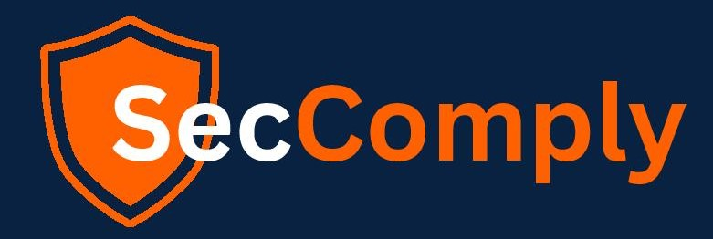

# Acceptance Usage Policy

**Owner: Atharva**

*Generated: 7/4/2025*

*Note: This is a fallback document generated because the original template couldn't be processed.*

Based on template: Acceptance Usage Policy

This is a policy document for SecComply.

Document owner: Atharva